Audience Specific Visualizations

Michael Surdek

Southern New Hampshire University

I chose to create visualizations for three separate audiences using the automotive safety recall data from NHTSA. The audience of the first visualization is on the consumer side and the audiences of the second and third are teams or management groups that I believe exist on the manufacturing side.

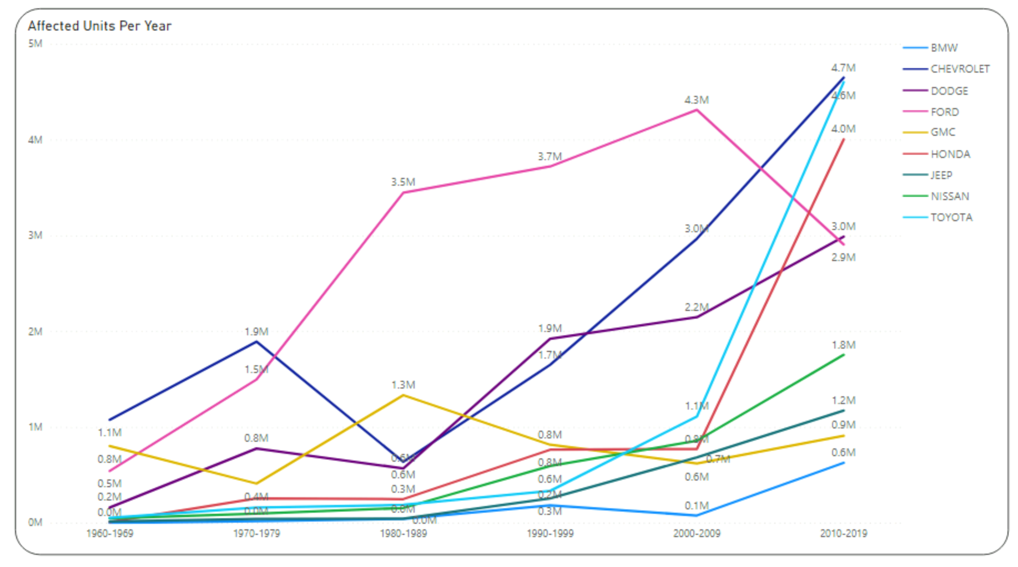

This line chart shows the average affected units per year in each decade from the 1960s to the 2010s from each of the nine most common car makes. The specific audience for this visualization is today’s potential car buyers. The message of the visual is to show historical data and recent trends of how many units are affected by recalls each year from the various car makes. Potential car buyers would likely be familiar with each of these car makes and might be only choosing between a few or a handful of makes based on other factors. The audience will vary highly in the characteristics of education levels, age, language, and cultural diversity, but the lines in the chart are easy to read and are labeled with actual numbers to assist in the readability. A lot of information can be gathered from the chart about affected units as a whole and the trends from each make over time. It is easy to see that the total number of affected units per year is increasing over time across the car industry, with a particularly large increase from the 2000s to the 2010s. Ford was responsible for the most affected units from the 1980s to the 2000s, but it was the only make whose affected units per year decreased from the 2000s to the 2010s. The makes that saw the largest recent increases in affected units per year were BMW, Honda, Chevrolet, Nissan, and Dodge. Potential buyers could use this information to help their car buying decision if they are concerned about purchasing a new car free from problems. Additional data that could provide more information to this audience would be the total number of cars manufactured per year by each make, because the ratio of affected units vs total units could be more important than just the total amount of affected units per year.

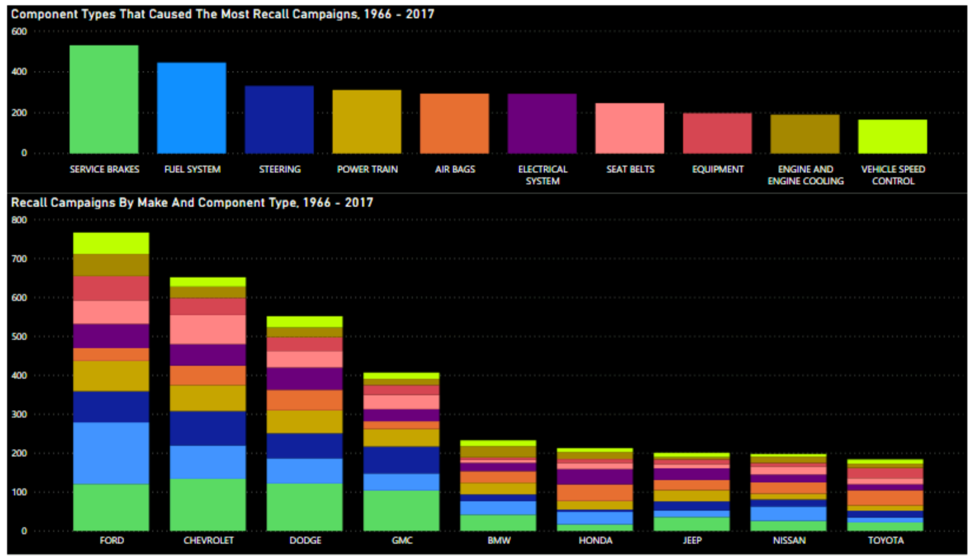

These bar charts show the car component types that have caused the most recall campaigns, both across all makes and for each of the nine most common makes individually. The specific audience for this visualization is a team of quality control workers for a manufacturer who is trying to lower their risk of recalls. The purpose off this visual is to highlight the areas of car manufacturing that lead to the most frequent issues, so that improved systems or protocols targeted on these areas can be put in place when manufacturing all cars or when focused on one make. The quality control team would be quite familiar with the issue at hand and the terminology, from the vehicle makes to the component types. Considerations such as education level and language would not be much of a barrier when it comes to this visualization. The age of each audience member might impact what they take away from the chart. Since the data ranges over 50 years and the design and quality of the components have changed over time, experience from age might offer additional insights into which systems and protocols would be more beneficial to cars that are being made today. On Power BI, the visualization had the interactive capability of spotlighting each individual component type by clicking on the bars of either chart. This would help the audience dig deeper into the data to discover comparisons among component types across makes. For example, a larger percentage of the total recall campaigns were caused by service brakes and seat belts for Chevrolet vehicles than the rest. The same could be said for Honda and Toyota when it comes to recall campaigns caused by air bags. The quality control team would be able to discover more information from this visual and use it to lower the risk of future recalls on the cars they are currently manufacturing.

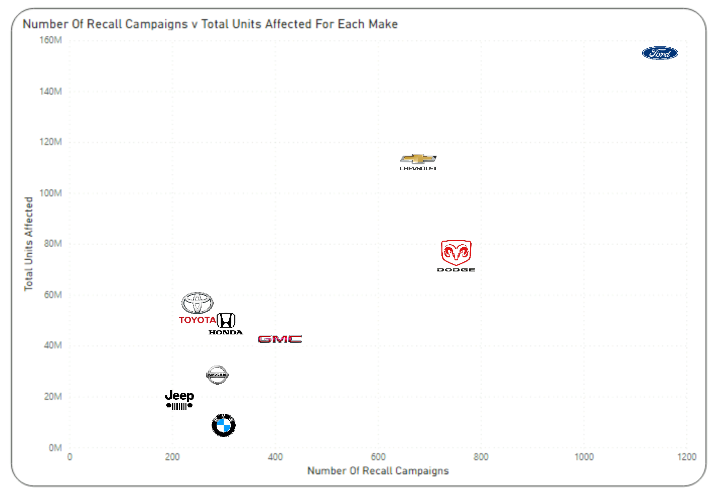

This scatterplot shows the linear relationship between the number of recall campaigns and the total units affected for each of the nine most common car makes. The specific audience for this visualization is a manufacturing company management team who is deciding which manufacturing contracts to accept from various car makes. The purpose of this visual is to show the management team which car makes have historically had the most recall campaigns and how many units those campaigns potentially affected in order to help their decision when it comes to which manufacturing contracts to pursue or accept from different car brands. The manufacturing company’s management team would understand which car makes they are considering and would easily identify their logos on the scatterplot. They would be looking for car makes that have been responsible for both fewer total recall campaigns and fewer units affected per recall. Similar to the quality control team, age and experience could be a factor due to audience members’ prior dispositions about certain car makes, but the extent to which things such as education levels and cultural diversity vary within the team would not have much of an impact on overall message of the visualization. Information that can be observed at a glance of the chart might include BMWs causing many recall campaigns but not having a large number of units affected from them, and vice versa for Toyota. As with the first visual above, gathering additional data on the total number of vehicles manufactured each year by each make and displaying the information as a ratio of total units might provide better insight. This information would not be the deciding factor for the management team, but this chart could be a helpful resource in the process.